ACTIVITIES IN CHURCH
Sunday 11.00am Family Church Service
Communion monthly
Curling after Sunday service (twice monthly)

Monday 9.45am U3A Bridge Class
10.00am-12.00 - Bee connected (weekly)
1.30pm U3A Scottish Dancing
2.00pm Monday Fellowship (twice monthly)
6.30pm St John’s Ambulance

Tuesday 10.00am Zumba Gold exercise class
11.00am Pulmonary Rehab Clinic
1.45pm Sequence Dance
7.30pm Huddersfield Miniatures (2nd in month)
6.00pm Huddersfield Choral Society (rehearsals)

Wednesday 9.00am Tumble Tots
10.00am Drop-In Coffee morning/dominoes
10.00am Knit & Natter - Lunch 12noon
7.30pm Friendship Club Dance

Thursday 10.00am U3A Mahjong
12.30pm Pulmonary Rehab Clinic
12.30pm Pulmonary Fibrosis Support Group
(1st in the month)
2.00pm U3A Social Bridge

Friday 10.30am Living Well with Dementia (weekly)
1.30pm Latin Class
2.00pm Shared Harmonies (weekly)

Saturday 10.00am-11.30am Coffee Morning
9.00am Tumble Tots

Weddings, Baptisms and Funerals by arrangement.
Contact: Church Office 01484 430556 email - office@moldgreenurc.org.uk
Enquiries for room hire – email - bookingsformurc@outlook.com
Activities are weekly unless otherwise stated.

UNITED REFORMED CHURCH
MOLDGREEN HUDDERSFIELD
WORKING FOR CHRIST AND THE COMMUNITY
NOVEMBER 2025

Moldgreen is part of the Huddersfield.
Pastorate of United Reformed Churches



Mission Statement
“WORKING FOR CHRIST AND
THE COMMUNITY”
What we believe
We believe in God, source, and sustainer of creation.
We believe in God, revealed in Jesus Christ, the eternal
Word of God made flesh.
We believe in God, ever present in the Holy Spirit who
Brings the Gospel to fruition.
How we achieve our mission
We are a fellowship of people who seek to worship God
through our lives and witness to other people.
We take seriously our responsibility to share our faith and
Love with others and are seeking avenues of service and mission in our church, homes, community, and places of work.
We seek to prepare ourselves for this mission to others
through our prayers and obedience to God’s will.

UNITED REFORMED CHURCH
MOLDGREEN
www.moldgreenurc.org.uk
Church office: tel. 01484 430556
Email: office@moldgreenurc.org.uk
bookingsformurc@outlook.com
Old Wakefield Road, Moldgreen, Huddersfield HD5 8AA
“WORKING FOR CHRIST AND THE COMMUNITY”

Minister of Word Community Minister
and Sacrament Helen Snashall
Revd Sarah Fitton helensnashall21@gmail.com
revsarahfitton20@yahoo.com
Community Worker
Sue Cockcroft
Sue@s2r.org.uk

Church Secretary Finance Secretary
Mrs Christine Hall Mrs Jean North
hallchristine748@gmail.com northjean00@gmail.com

Church Treasurer Maintenance Team
Mr Ian Whitehead John North
matty-whitehead@lineone.net j60nth@gmail.com
George Straughan
Magazine Editor Kevan Shuttleworth
Mrs Jean Whitehead John Startin
office@moldgreenurc.org.uk Stephen Taylor


page 1

NOVEMBER 2025
Hello All,

In November we welcome a time of Remembrance. It’s the space between Harvest celebrations, pumpkin lattes, the rustle of the leaves and the creeping in of the delights of December – dare I say it… Advent and November can often be overlooked, it has its own time, in its own right. Let us hold on to the importance of our church life and faith at this time. Let us be servants of remembrance. Let us observe what Jesus says to us;
‘I am the resurrection and the life, says the Lord; those who believe in me shall live, even though they die, and no one who lives and trusts in me shall ever truly die.’ (john 11 v 25,26)

This month balances the dark, that surrounds us, with the light of eternal hope, eternal life, eternal Good News. The Light of the World. Let us remember and be assured that whatever we face in our lives, and whatever the world has to face, God is present. So, we light candles, we light the way as Christians to the true light that never goes out – Jesus.
Can I invite you to light a candle each week, on Sundays at 7pm and pray a November Prayer of remembrance together. (when finishing the prayer please remember to extinguish the candle)
Let us Pray………..
This light is for those I want to remember
This light is for those I miss
This light is for those who need hope
This light is for those who need healing
This light is for those who grieve, who are angry, who are in pain
This light is for those who have sacrificed, served and been faithful
This light is for those who are unseen but are the subject of the news headlines
This light is for those who work for peace
This light is for our church, community and town.
This light is a light as a prayer beyond words. Amen
Many Blessing to you all, Rev Sarah Fitton page 2

Film club – Faith Questions: ‘Because Faith is all around us’
I want to thank Janet for all the amazing film choices in 2025 – 2026 and for supporting me in adding to the fun and enjoyment of film club, by introducing an optional, added extra. I am someone who loves films of all kinds. I also like to challenge myself, by thinking, how these films impact my faith even when they aren’t overtly faith based. I thought you might like to give it a try - I will be putting together questions for you to reflect on as you watch each film and to look over in your own time. I will make sure you have access to them here in the magazine and also on the day of film club. This is just for your private faith reflections.
Here are the Faith Questions for Billy Elliot • What gifts come naturally to you? • When life is stressful, how do we try to hold it together for ourselves and for our family? Do we ever ask for help – even from God? • Why do we get so fearful of the ways other people express themselves? • Does God give us opportunities to make us confident and brave? • Who are, our teachers, in our life today? • What do you dream of - what sets you free and lifts you up?
Here are the Faith Questions for An Ideal Husband • What do we expect from our Politicians or Public Figures? • How important is reputation and would you do anything to protect it? • What qualities do you find important in a partner, friend, husband or wife? • Whose opinion matters the most about who you are God, yourself, your spouse or society at large? • What is your view on power and control; and how it is exercised.

page3
News of the church family
We hope you are all keeping well, it is lovely to see our regular congregation on a Sunday and those from our Waverley pastorate who join us and not forgetting our ‘zoomers’ at home, plus new people who we have welcomed to church as well. We also welcome our regular groups and new groups who hire space during the week.
We do hope you will continue to pray for all our church fellowship, friends and family, our local community, and the wider world.
Please continue to remember our members and friends,
Margaret Hines and Audrey Greenwood, who are both in residential homes and living nearer to their families. We also remember those who live at home and are not able to come to church. If you are able, please do keep in touch with people, a telephone call and a chat is always appreciated.
We send our love and prayers to Alan and June Atkinson, and they send their regards to everyone at church.
Please continue to remember many others in our fellowship who are going through difficult health problems, and we send our love and
prayers to them all. We ask you to remember and pray for all these people mentioned and others known to you who are unwell or
experiencing difficulties. Remember those who are caring for their loved ones and those of our fellowship, pastorate, family, and friends who have been bereaved.

ADVENT SESSION DATES

You are invited to celebrate Advent with us at our Refresh and Renew sessions on Zoom. We are running three zoom sessions
on the following dates: December 4th, 11th, 18th – at 7.00pm
Meeting ID: 775 6331 5040 Passcode: cxE834
This year we are looking at the places and spaces of Christmas.
We shall read the Christmas Story together and look at the markers

page 4
along the way. We call to register, journey on the road to
Bethlehem, the innkeeper’s stable, God from heaven to earth and the Holy Family’s displacement to Egypt.
We welcome you to share in the fun, learning and reflection of the season with good friends and family.

DATES FOR YOUR DIARY IN NOVEMBER
Nov 1st Saturday Coffee Morning 10.00am-11.30am
Nov 1st World Day of Prayer preparation
Nov 2nd Family Church Service 11.00am
Followed by curling after the service
Nov 3rd Bee Connection - Craft Workshop 9.30am-12.30pm
Nov 5th Drop In from 10.00am/Knit & Natter- Lunch at 12.00am
Nov 7th Living Well with Dementia 10.30am-2.30pm
Nov 8th Saturday Coffee Morning 10.00am-11.30am
Nov 9th Remembrance Sunday Service 11.00am
Nov 10th Bee Connection - Craft Workshop 9.30am-12.30pm
Nov 10th Monday Fellowship 2.00pm
Nov 12th Drop In from 10.00am/Knit & Natter- Lunch at 12.00
Nov 14th Living Well with Dementia 10.30am-2.30pm
Nov 14th Spot On Musical Theatre presents a Kaleidoscope of
Talent – at 7.00pm - Tickets £7.00 to include
refreshments. See poster on church notice board.
Nov 15th Saturday Coffee Morning 10.00am-11.30am
Nov 16th Family Church Service 11.00am
Nov 17th Bee Connection - Craft Workshop 9.30am-12.30pm
Nov 18th Elders Meeting 9.30am – on Zoom
Nov 19th Drop In from 10.00am/Knit & Natter- Lunch at 12.00am
Nov 21st Living Well with Dementia 10.30am-2.30pm Living
Nov 22nd Saturday Coffee Morning 10.00am-11.30am
Nov 23rd Family Church Service 11.00am - Communion
Nov 24th Monday Fellowship 2.00pm-Christmas Celebration
Nov 25th Garden - Planter tidy session 10.00am-12noon
Nov 26th Drop In from 10.00am/Knit & Natter- Lunch at 12.00am
page 5
Nov 28th Living Well with Dementia 10.30am-2.30pm
Nov 29th Ravensknowle Gala Christmas Fayre10.00am-4.00pm
Nov 29th Please note there will not be a Coffee Morning on 29th.
Nov 30th Joint Pastorate Service at Waverley URC - 11.00am
No Service at Moldgreen URC

Church Meeting dates for your diary in 2025
Sunday December 14th after church service
Elders meeting 18th November 9.30am
Check the back of the magazine for more information of what’s happening in the church and on the notice board. Please make a note of the dates in your diary.

SUNDAY SERVICES IN NOVEMBER
All services start at 11.00am unless otherwise indicated.
Nov 2nd Janet Straughan
Nov 9th Rev Sarah Fitton/Remembrance Service
Nov 16th Rev Angela Lawson
Nov 23rd Rev Sarah Fitton – Communion
Nov 30th Joint Pastoral Service at Waverley URC

DUTY ELDERS IN NOVEMBER & DECEMBER
Nov 2nd Jean Whitehead
Nov 9th Julie Johnston
Nov 16th Christine Hall
Nov 23rd Janet Straughan
Nov 30th Joint Pastorate Service at Waverley URC 11.00am
Dec 7th John North
Dec14th Kevan Shuttleworth
Dec21st Mark Binns
Dec 28th Joint Service at Waverley URC 11.00am

page 6
FLOWERS IN CHURCH FOR NOVEMBER & DECEMBER
The flowers in church on Sundays are taken out to those who are ill or in need of pastoral care. We are grateful to all in our fellowship who give money for flowers throughout the year. If you are not

already on our ‘flower list’ but would like give flowers, please speak
to Jean Whitehead, call 01484 430556 or email to
office@moldgreenurc.org.uk to arrange this.
Nov 2nd Donation
Nov 9th In Memory of Terry & Doreen Proud
Nov 16th Stephen & Pauline Taylor
Nov 23rd Margaret Ellis
Nov 30th Joint Pastorate at Waverley-no service at MURC
Dec 7th John & Jean North
Dec 14th Margaret Hines
Dec 21st No morning service at MURC
Christmas Lunch at 1.30pm
Joint Carol Service at 4.00pm
Dec 25th In Memory of Margaret Pickup

MONDAY FELLOWSHIP
Very little to report for October as, due to a Synod event at Church, the early October Fellowship meeting was cancelled leaving us simply with the 27^{th of} October meeting. Therefore, on the last Monday of October one of our regular visiting speakers, David Glover, comes to Moldgreen again to tell us all about the many lost descendants of King Henry V111 and we know how prolific he was with his favours. This is likely to be most revealing, and I am sure it will be very interesting.
This brings us on to November when John and Jean North will test us with another of their general knowledge quizzes. That more or less concludes the list of normal meetings as towards the end of November we will enjoy a Christmas celebration when we again have some Christmas fare to eat and drink and enjoy one of Kevin Shuttleworth’s Christmas bingos and
page 7

quiz, reminiscent of those regularly enjoyed by our Friday Dementia group
members to finish off the afternoon; apparently this always goes down
very well indeed.
December sees us enjoying our usual 3 course lunch on Sunday 21st of December to finish off 2025 as of course there will not be a meeting on 22nd as it is too near to Christmas day. Well before the day of the luncheon, a menu and list will appear on the Church notice board where you will need to indicate your intention to come and your choice of food.
The meeting schedule for the rest of 2025 is as follows: -
27th Oct. David Glover – “Lost Descendants of King Henry V111”
10th Nov. John and Jean North. - General knowledge quiz.
24th Nov. A Christmas Celebration.
21st Dec. 3 Course Christmas Lunch at 1.30pm. (Note – this is on a Sunday.) There will not be a Church Service in the morning. There will be the usual Carol Service at Moldgreen, but at 4.00pm after the lunch.
As ever, fortnightly generally on Monday afternoons at 2pm in the small meeting room – do come along and support the Monday Fellowship. George Binns

HARVEST Thanksgiving Service – Sunday 12th October
Community Food Cupboard
Thank you to everyone who donated to our Community Food Bank at our Harvest Thanksgiving Service, in goods and cash donations. Our cupboard has been replenished. All donations are welcome at any time. Thank you.



page 8
Xmas Magic Appeal
Despite Sue Carter being out of action with a broken ankle plans for this year’s Xmas magic appeal are well under way and any donations would be appreciated.
Can you help to bring a little “Christmas Magic” to households in need across the Dalton Ward donating:
New unwrapped toys, games, books for all ages, and gifts suitable for babies, children, teenagers and adults (males and females)
Selection boxes, Family boxes of chocolates and biscuits
Crisps and nibbles E.g. Pringles (no nuts)
Non-perishable food items such as selection boxes, tubs of sweets, chocolate items, biscuits, crisps, nibbles, pringles. (No nuts)
Please make sure that edible goods can last throughout December into January and any gifts come unwrapped and are new.
Cash donations also welcome so items can be purchased.
Please give any donations to Sue Carter or Helen.
If you'd like more information or have any questions, please contact Sue Carter on 07834 590446.
P.S. We are pleased to say Sue has recovered and now back on her feet.

CURLING
We meet on alternate Sundays after the morning service. New players welcome, full training and refreshments. Bring your lunch.
Dates - November 2nd and 16th and December 7th.
SATURDAY COFFEE MORNING
Saturday Coffee dates in November
November 1st, 8th, 15th, 22nd, 29th 10.00am – 11.30am
All Welcome

page 9
Celebrating a fruitful first year with Helen as our CRCW
Below is a report written by Helen for Synod that was featured in the Synod newsletter in October.
I started as the new CRCWm in the Huddersfield pastorate at the beginning of September 2024 and it was lovely to have my Mum and friends join with the pastorate for my commissioning service when the Revd Dr Noel Irwin used a text from Nehemiah to speak about my passion for encouraging others to discover their talents and ‘build’ and for working with others and for my love of a good cup of tea!
A lot of my first 3 months were taken up with attending the annual CRCW residential and the courses and events that someone new to ministry has to undertake. However, I was also able to start to get to know Huddersfield, particularly the areas around both churches, start to build relationship with other groups and organisations and to support our pastorate community worker (who started in June 2024) with some of the activities she was running.
In addition to supporting existing groups at both churches and running some one-off activity sessions at Moldgreen we established the Warm Welcomes at Moldgreen, a monthly drop-in session offering people the chance to call in for a brew, get advice and support if required and to have a go at some different craft activities. This was in response to the closure of another group that used to meet in Moldgreen’s building.
The run up to Christmas was a busy time with some extra craft sessions, a Christingle celebration with Moldgreen community primary school and the fantastic little lights switch on, lighting up Moldgreen’s new living Christmas tree.
I have got involved with the planning of the Fabulous Friday sessions as well as helping at some of the sessions. Fabulous Friday is a joint project between Waverley URC and the FOCAL centre offering exercise sessions, crafts and occasional talks to older residents. We have seen some participants also come to Waverley’s weekly coffee morning and a couple

page 10
of people occasionally come to the Sunday services.
During August we ran holiday activities for families at both churches. This was a new initiative, and it was great that so many people from both churches got involved and we could engage with lots of new families. Check out our video here https://youtu.be/krkKuPTjvqs – we even had a teddy bears picnic as well. We are looking forward to running some more sessions over October half term.
We have secured extra funding towards our work with the community to run extra activities sessions, improve the church garden and to support people facing hardship through the national household support fund.
As well as work with the churches here at Moldgreen and Waverley I have also become a governor at Moldgreen community primary school, am involved in some wider work with the team at the FOCAL centre where Waverley are based and am now the chair of Dalton Together, a community partnership, which Rosie Buxton, Moldgreen’s previous
CRCW was instrumental in establishing.
I was encouraged to hear someone talking about Moldgreen URC and the Unite Respect Connect project a few months ago and saying they wished more churches were prepared to be involved in their community in the way we are. Having the capacity to get involved in community life without any agenda apart from, “we care because God cares” helps both churches build trust and grows relationships.

Do you have a nativity set we can borrow?
Last year the church looked lovely inside and out with the new nativity set in the foyer and the wooden stable scene outside. This year, on Saturday 6th September when we will be switching the tree lights on (a new tree is coming) we’d like to display a variety of nativity sets in the church for people to view as part of the activities.
Please don’t lend us your precious family heirlooms or expensive sets as we can’t guarantee their safety during a busy session but if you’ve got anything nativity themed you can offer for the evening please speak to Helen. page 11

ACROSS ANSWERS ON PAGE 20
1 The sixth disciple (Matthew 10:3) (11)
9 ‘And lead us not into temptation, but deliver us from the — — ’ (Matthew 6:13) (4,3)
10 Love intensely (Song of Songs 1:4) (5)
11 From Mt Carmel to Jezreel, Elijah — all the way (1 Kings 18:46) (3)
13 One of the Midianite leaders who was captured and killed after Gideon’s victory in the valley near Moreh (Judges 7:25) (4)
16 Metallic element (4)
17 At line (anag.) (6)
18 ‘Cursed is everyone who is — on a tree’ (Galatians 3:13) (4)
20 Where Samson killed a thousand Philistines with a donkey’s jawbone (Judges 15:14) (4)
21 He succeeded Moses (Deuteronomy 34:9) (6)
22 ‘When he saw him, he took — on him’ (Luke 10:33) (4)
page 12
23 ‘For — is the gate and broad is the road that leads to destruction’ (Matthew 7:13) (4)
25 ‘The god of this — has blinded the minds of unbelievers’
(2 Corinthians 4:4) (3)
28 Fear or terror (Psalm 31:22) (5)
29 ‘We, who are many, are one body, for we all — of the one loaf’
(1 Corinthians 10:17) (7)
30 Assyrian ruler assassinated by his sons while worshipping his god Nisroch (2 Kings 19:37) (11)

DOWN
2 ‘For as in Adam all die, so in Christ all will be made — ’
(1 Corinthians 15:22) (5)
3 ‘After supper he — the cup’ (1 Corinthians 11:25) (4)
4 The request of a man of Macedonia in Paul’s vision: ‘Come — to Macedonia and help us’ (Acts 16:9) (4)
5 He disobeyed his father Judah by refusing to impregnate his dead brother’s wife (Genesis 38:9) (4)
6 I veto me (anag.) (7)
7 Fourth king of Judah (1 Kings 15:24) (11)
8 Priest of God Most High, who blessed Abram (Genesis 14:18) (11)
12 ‘I have made you — — for the Gentiles’ (Acts 13:47) (1,5)
14 Implore (1 Samuel 15:25) (3)
15 ‘Out of the eater, something to eat; out of the — , something sweet’ (Judges 14:14) (6)
19 ‘I am the most ignorant of men; I do — — a man’s understanding’ (Proverbs 30:2) (3,4)
20 ‘Sin shall not be your master, because you are not under — , but under grace’ (Romans 6:14) (3)
24 Native of, say, Baghdad (5)
25 The last word in the Bible (Revelation 22:21) (4)
26 Heroic tale (4)
27 ‘Then you will know the truth, and the truth will set you -’(John 8:32) (4) page 13
The Poppy Appeal – could you help by giving some time this autumn?
The 2025 Poppy Appeal will be launched this month. The Poppy is a powerful symbol worn by people right across the UK to commemorate the sacrifices of our Armed Forces and to show support to those still serving today. The Royal British Legion was first set up to help those returning from the First World War. Almost a century on, they're still helping today's service people, veterans, and their families coping with bereavement, living with disability or finding employment. However, the Poppy Appeal would not be able to continue without the dedication of the teams of volunteers who stand in the streets, shops and supermarkets.
Each town and village has their own Poppy Appeal Organiser - also a volunteer - who runs these teams, arranges for cover, drops off and
collects the boxes. The Poppy Appeal is always grateful for the work of these dedicated people, but the volunteers say they are proud to be selling poppies to show support for those who sacrificed their lives for us. If you want to volunteer, or if you would like a visit from a local volunteer who can speak to your community/church group, please go to: https://www.britishlegion.org.uk/get-involved/volunteer

St Andrew and football - by Canon Paul Hardingham
‘Some people think football is a matter of life and death. I don't like that attitude. I can assure them it is much more serious than that’ (Bill Shankley). When you replace the word ‘football’ with ‘mission’, this quote still has something to say! The apostle Andrew (we remember him on 30th November) demonstrates what the mission of the Church is all about
(John 1:35-42). It’s not unlike following your favourite football team!
When we support a football team, we make sure that we know all about them! When Andrew and his friend heard about Jesus, they wanted to find out more: ‘Look, the Lamb of God.’ (John the Baptist, v35). The first stage of mission is finding out more about Jesus, the One who enables us to be friends of God through His death and resurrection.
page 14
Secondly, when supporting a football team, we will spend time watching their games. Andrew asked, ‘where are you staying?’ and Jesus replied, ‘Come and you will see’ (v39). Andrew spent the rest of the day talking and listening to Jesus. As a result of this time, he had something to share. How much time do we spend with Jesus, reading His word and praying?
When our team wins, we want to share the good news! After meeting Jesus, Andrew’s first action was to tell his brother Peter: ‘We have found the Messiah’ (that is, the Christ)’ (v41). Are we willing to tell others about Him too? Sharing with family and close friends can sometimes be harder than talking with strangers. However, we don’t need to follow a football
team to engage in mission. It’s all about being excited to share Jesus with those we meet day by day. SOURCE: THE PARISH PUMP

16th November - St Margaret of Scotland
Some women have power, and some women are good. When a woman with power is also good, she can achieve an astonishing amount.
Margaret of Scotland has been called ‘The Pearl of Scotland’, but she began life in Hungary about 1045. She was born to the expatriate English prince Edward the Exile, and so was an English princess. The family returned to Wessex in 1057, when she was 13, and following the death of King Harold II at the Battle of Hastings in 1066, her brother Edgar Aetheling should have been King of England, but he was never crowned. Instead, the family fled north, to Scotland, where she was married to Malcolm III of Scotland by 1070. As a Scottish queen she went on to become mother of three kings of Scotland, and of a queen consort of England.
Margaret was a Christian, and became a good friend of Lanfranc, a future archbishop of Canterbury. Her biographer tells of how she read narratives from the Bible to her husband, thus helping to ‘civilise’ him. He was illiterate, but so admired her reading, that he had her books decorated with gold and silver. She was also credited with helping her youngest son, the future King David I of Scotland, towards becoming a just and holy ruler.
Margaret introduced the worship and practise of the Church of Rome into
page 15
Scotland. She also wanted to help the many pilgrims travelling in Scotland, and so she established a ferry across the Firth of Forth, which is where the towns South Queensferry and North Queensferry got their names.
Margaret performed many charitable works for the poor, and she interceded for the release of English exiles who had been forced into serfdom following the Norman conquest. She also began the restoration of Iona Abbey. In private life, Margaret spent much of her time in prayer, using a cave on the banks of the Tower Burn in Dunfermline as a place of devotion and prayers. St Margaret’s Cave is still there today, covered beneath a municipal car park. Margaret died in 1093, and in 1250 Pope Innocent IV canonised her. Her relics were dispersed after the Scottish Reformation, but at one time Mary, Queen of Scots, owned her head.
SOURCE: THE PARISH PUMP

Take it easy on those country roads

Country roads may look inviting to drive, but the statistics tell a different story. For collisions on rural roads are around four times more likely to result in a fatality.
Such is the finding of the NFU Mutual Rural Road Safety Report 2024. It found that in 2023, an average of one in every 32 collisions on rural highways resulted in a death, compared to one in every 122 on urban roads. Overall, more than 18 people died on rural roads each week in 2023.
So - what is wrong? It seems it is the sheer number of hazards which motorists may face on a rural road. These include blind corners, narrow roads, road quality, poor visibility, cyclists, pedestrians, horse riders, mud and debris, loose livestock, agricultural vehicles, unexpected road or field entrances, impatient drivers, and Sat-Navs sending people down unsuitable roads. It all adds up to one simple message: be careful and expect the unexpected on country roads.

page 16
Prayer for November 2025 by Daphne Kitching
Heavenly Father,
Here we are in November – the month of short, dark days. A dreary, difficult month, unless you have a birthday! Lord, it seems as if the world is permanently in November at the moment. So much is so difficult for so many people, through no fault of their own. And it seems to go on and on.
Lord, would You bring your healing light into the world’s darkness. Bring transformation, compassion and a softening into the hearts of those with responsibility for the conflict and the suffering, that they might work for peace for all people. We know that nothing is impossible for you, Lord, so we pray in faith – and in the name of Jesus. Amen.

All in the month of November
175 years ago, on19th November 1850 that Alfred, Lord Tennyson, became Poet Laureate of the UK (until 1892).
125 years ago, on 22nd November 1900 that Arthur Sullivan, British composer, died. Best known for his collaborations with the dramatist W S Gilbert on operas including H.M.S. Pinafore and The Pirate of Penzance. He also wrote the hymn Onward, Christian Soldiers.
100 years ago, on 10th November 1925 that Richard Burton, Welsh stage and film actor was born. Known for Cleopatra, Who’s Afraid of Virginia Woolf? And many more. Fifth and sixth husband of Elizabeth Taylor. Died 1984.
Also 100 years ago, on 27th November 1925 that Ernie Wise, TV comedian and actor, was born. Best known for his comedy partnership with Eric Morecambe (Morecambe and Wise) Died 1999.
90 years ago, on 6th November 1935 that Britain’s Hawker Hurricane fighter plane made its first flight. It played a major role in WWII, especially during the Battle of Britain.
80 years ago, on 16th November 1945 that UNESCO, the United Nations Educational, Scientific and Cultural Organisation, was founded.
page 17
75 years ago, on 2nd November 1950 that George Bernard Shaw, Irish playwright and literary critic, died. Best known for Pygmalion. Winner of the 1925 Nobel Prize in Literautre, and co-founder of the London School of Economics.
65 years ago, on 2nd November 1960 that a British jury cleared Penguin Books of obscenity for publishing D.H. Lawrence’s novel Lady Chatterley’s Lover. This is often considered the beginning of the permissive society in Britain.
Also 65 years ago, on 8th November 1960, that John F Kennedy was elected as the 35th President of the USA.
60 years ago, on 9th November 1965 that the death penalty was abolished in the UK
50 years ago, on 3rd November 1975 that Britain’s first North Sea oil pipeline was officially opened.
40 years ago, on 15th November 1985 that the Anglo-Irish Agreement was signed by the Prime Minister Margaret Thatcher and Irish President Garret Fitzgerald. It gave the Irish government a consultative role in the affairs of Northern Ireland.
25 years ago, on 9th November 2000 that Eric Morley, TV host, died. Known for establishing the ballroom dancing competition Come Dancing (1949 – 98). It was succeeded by a celebrity version, Strictly Come Dancing, in 2004.
20 years ago, on 30th November 2005 that John Sentamu became Archbishop of York (until 2020). He was the first black archbishop in the Church of England.
10 years ago, on 13th November 2015 that the Paris Attacks took place when suicide bombers and armed terrorists from Islamic State (IS) attacked a football stadium, rock concert, cafes and restaurants. 130 people were killed and 416 injured. IS said the attacks were in retaliation for French air-strikes on IS targets in Syria and Iraq.

page 18
Careful!
There was a very gracious lady who was mailing the old family Bible to her brother in another part of the country. "Is there anything breakable in here?" asked the postal clerk. The lady thought for a moment. "Only the Ten Commandments."

Morning
There are two kinds of people in the world. There are those who wake up in the morning and say, "Good morning, Lord," and there are those who wake up in the morning and say, "Good Lord, it's morning."
Hear, hear
A very deaf elderly man was finally fitted out with a hearing aid that really worked. A month later his doctor called him in for a check-up. “Your family must be really pleased that you can hear again.” The gentleman replied, “Oh, I haven't told my family yet. I just sit around and listen to the conversations. I've changed my will three times!”

Where there’s smoke…
At our church, it was common for the minister to invite the children to the front of the church and have a small lesson before beginning the sermon. He would often bring in a household item and then relate it to a teaching from the Bible. One morning, the visual aid for his lesson was a smoke detector. He asked the children if anyone knew what it meant when an alarm sounded from the smoke detector. My young son immediately raised his hand. “It means Daddy's cooking dinner."

Bible knowledge
A minister was approached by his small son who told him proudly, "I finally figured out what the Bible means!” The minister thought of his extensive theological library and smiled indulgently. He asked his young son what he thought the Bible meant. "It’s easy, Daddy," the boy replied. “It means: 'Basic Information Before Leaving Earth.'”

page 19
MAGAZINE SUBSCRIPTIONS FOR 2026
The subscription for the 2026 magazine is now due. Whether you receive your magazine by email or paper copy the cost is the same £10.00. Yvonne Goude will be collecting your subs on a Sunday in November and December by cash or cheque payable to United Reformed Church Moldgreen. You may also pay by Bank transfer – sort code: 30-94-43 a/c no.00260324
Reference: Church magazine. Please pay your subscription, if possible, by the end of December.
****************************************************************************

If you have any material or news of the church family you would like including in the DECEMBER/JANUARY joint magazine, please give material to Jean Whitehead by hand, post or email to office@moldgreenurc.org.uk on or before SUNDAY
for the magazine deadline.

**********************************************************************************************

RECYCLING
There is a basket in the church entrance where you may deposit any old Christmas cards/Birthday cards etc. Plus, a box to put used postage stamps in. Also, there is a bin in the kitchen where you can recycle plastic bags which have a green label on indicating recycle at local supermarkets.

ANSWERS TO CROSSWORD
ACROSS: 1. Bartholomew. 9, Evil one. 10, Adore. 11, Ran. 13, Oreb.
16, Zinc. 17, Entail. 18, Hung. 20, Lehi. 21, Joshua. 22, Pity. 23, Wide.
25, Age. 28, Alarm. 29, Partake. 30, Sennacherib.
DOWN: 2, Alive. 3, Took. 4, Over. 5, Onan. 6, Emotive. 7, Jehoshaphat.
8, Melchizedek. 12, A light. 14, Beg. 15, Strong. 19, Not have. 20, Law.
24, Iraqi. 25, Amen. 26, Epic. 27, Free.

page 20
Songs of Praise and the nation’s favourite school hymn
This autumn the BBC has been in the process of discovering our favourite school hymn. It gave the public a shortlist of 50 hymns to choose from. The vote was organised by the BBC’s Songs of Praise team, with an accompanying programme, The Big School Assembly Singalong, hosted by singer and presenter Aled Jones.
Aled Jones well remembers his school hymn days. “Every morning, we sat cross-legged on an uncomfortable wooden floor, which doubled up as our gym and school canteen. “We would sing the songs that don’t get sung in cathedrals, where I ended up, because they’re perhaps seen as child-like, but actually that’s what brought me into religious music in the first place. “There’s a joy in being able to sing these hymns that uplift you and make you feel out of this world, but back at school, it was even better to do it with mates. I think that these hymns and this collective singing just takes you back to an easier, simpler, safer time.” The vote was cast on 20th September, but at the time of this going to press, we do not yet have the results.
The results were due to be announced on 11th October, during The Big School Assembly Singalong, held at the Victoria Hall in Bolton. On the night, a choir led by music teacher and TikTok star James B Partridge will present a range of school assembly classics. Partridge said: “I think the school assembly songs that we sang as children have a special place in our heart. Having that experience of singing together as a community really brings back the joy of those childhood days.”
Here is a full list of the hymns that the BBC offered.Which are your top five?
All Creatures of Our God and King All Things Bright and Beautiful
Autumn Days Bind Us Together
Black and White (The Ink is Black, the Page is White)
Cauliflowers Fluffy (Paintbox) Colours of Day (Light up the Fire)
Conkers! Cross over the Road
Do not be Afraid, for I Have Redeemed You From the Tiny Ant
Give Me Oil in My Lamp (Sing Hosanna) Glad that I Live am
page 21
Gloria in Excelsis Deo God Knows Me (hundreds of sparrows)
Go Tell It on the Mountain He’s Got the Whole World in his Hand
He Who Would Valiant Be If I had a Hammer
If I were a Butterfly I, the Lord of Sea and Sky
I Watch the Sunrise Kum ba yah (Kumbaya)
Lord of all Hopefulness Lord of the Dance
Make Me a Channel of Your Peace Mine Eyes have seen the Glory
Morning has Broken My Lighthouse
Oh, Jesus I have Promised One More Step Along the World
Peace, Perfect Peace Praise Him (Praise him in the morning)
Shine, Jesus, Shine Sing it in the Valleys
Spirit of God as Strong as the Wind Thank you, Lord
The Building Song (All Over the World) The Lord’s my Shepherd
The Wise Man Built his House upon the Rock Think of a World
This Little Light of Mine Water of Life
We are Climbing We Plough the Fields and Scatter
When a Knight Won his Spurs When I Needed a Neighbour
Who put the Colours in the Rainbow? Who’s the King of the Jungle?
We shall go out with joy


page 22

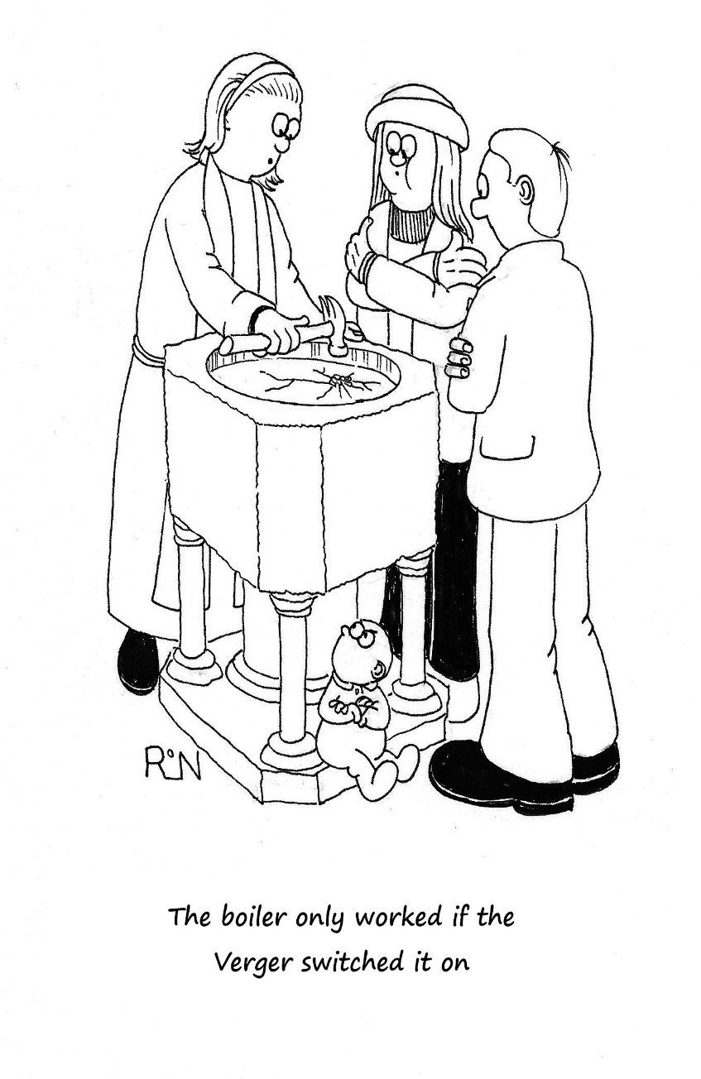

page 23

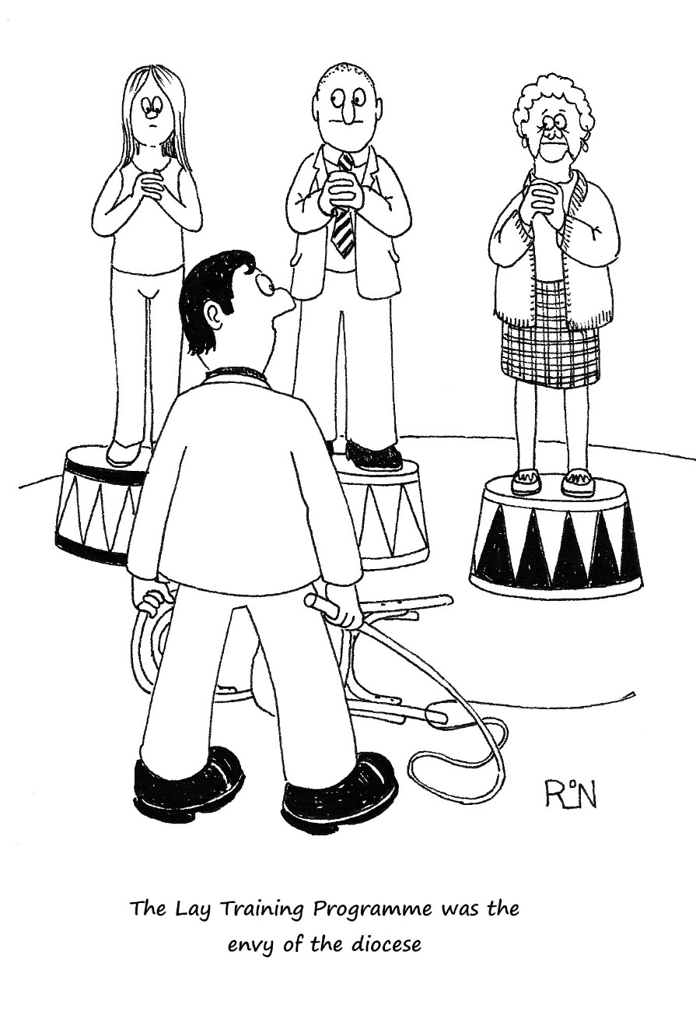

page 24



